ISO/IEC/CEN/CENELEC Commenting Template User Guide
User guide for Balloter and Commenter v3.0 (2017)

CEN/EDP Competence Center
10/16/2017

Table of Contents
Table of Contents 2
1. Introduction 3
1.2 Template header 4
1.3 Template body 5

Introduction
The ISO/IEC/CEN/Cenelec Commenting template is used by participants in committees and working groups during the balloting and commenting processes to submit their comments and observations to secretaries of ISO committees, convenors of working groups and project leaders.
The ISO/IEC/CEN/Cenelec Commenting template has been created in the Word 97-2003 format and can therefore be used with older versions of Word.
Please use only the authorized version of the commenting template for the submission of comments and do not modify the commenting template in any form (e.g. by deleting or adding columns or merging cells).

Rules to fill out the ISO/IEC/CEN/Cenelec Commenting Template
            - Do not modify the template, i.e. do not delete or add any columns, and also do not change the width of the columns.
            - Do not re-create the template using your own styles. Use only the original template made available by ISO/CS.
            - Each comment shall be entered in a separate row. Additional rows must be added manually to the commenting template, if required.
            - For each comment, fill out all mandatory fields

[2017] : Change introduced with the Online Comment Collation Tool
            - You may now add free text or a predefined Form after the original template table, as long as this new part of the document is separated from the Template table by a [Section Break]
            - You may also submit a Comment file using a predefined form without the template table.
ImportantNote :
Information submitted in specific forms or unstructured text cannot be sorted and collated together with comments from other balloters.
Therefore using this feature should remain an exception reserved for specific cases : predefined Assessment or Opinion forms, complex text or table impossible to fit in the normal template table

This user guide to the ISO Commenting Templates describes how to fill out and use the ISO/IEC/CEN/Cenelec Commenting Template. In case you need any further assistance, please contact the International Helpdesk in the ISO Central Secretariat (e-mail: helpdesk@iso.org).
The commenting template and a guide to its use are available on the CENTC server at :: http://cen.iso.org/livelink/livelink?func=ll&objId=1297552&objAction=browse&sort=name&viewType=1 in the " 03. Support to decision making : CEN-ISO Commenting template and Comment Collation Tool " folder.

The 2012 version of the template has been modified and contains an additional column (Line number). The previous version of the template (2001) is therefore no more compatible with the collation tool and will only be supported for a very limited period of time.
Therefore, use only the last authorized version of the commenting template for the submission of comments that is available at www.iso.org/e-guides.

Secretaries of ISO committees, convenors of working groups, project leaders and anyone who use the collation tool should download the latest version (2012) of the collation tool in order to be able to process the new templates.
The Collation Tool and a guide to its use are available at www.iso.org/e-guides.

The ISO Commenting template is composed of a Header and a body.
Template Header
Fill out the information about the document/project.

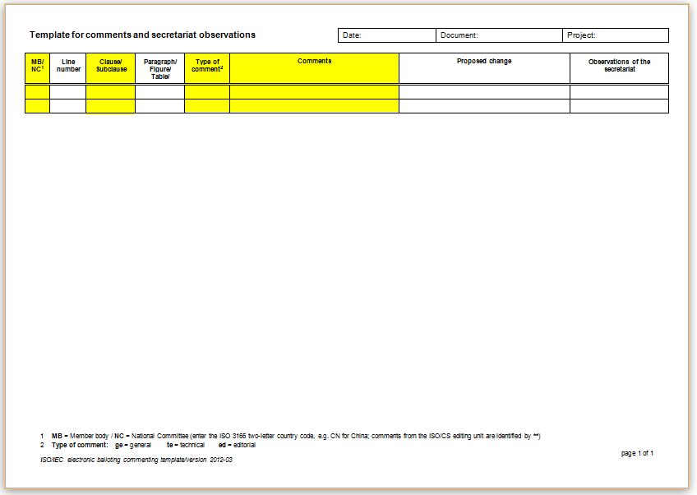
Template body
Write your comments in these fields. The columns marked in yellow are mandatory.

Template header
The ISO Commenting template header contain the main information about the document and/or project to be commented.

Field | Description
Date | Fill in the date when you submit the comments.
Document | Enter the project reference number of the draft standard to which your comments relate. For example: ISO/DIS 492
Project | Enter the project ID of the draft standard to which your comments relate. This number (ID) can be found in the Project details of the project in Project Portal. For example: for the project ISO/DIS 492 the Project ID is 60356. This field is optional.

Template body
The ISO Commenting template body is where you fill out your comments and observations. The fields in the table below marked with an * are mandatory and must be filled out for each comment line in the template.

Field | Description
MB/NC* | Fill in the two-letter country code for the country represented by the ISO member body [MB]. (NC is only used for IEC ballots)  The two-letter country code must be entered in each row, for each individual comment.  This field is compulsory and must be filled in.  NOTE 1  If the template is used by an external liaison organization or an ISO or IEC committee in liaison, the name or acronym of the liaison organization or the committee reference should be entered in this column.  NOTE 2  Comments prepared by the editing department in the ISO Central Secretariat will be indicated by a double asterisk "**" to distinguish these comments from the two-letter country codes used by member bodies.
Line number | Indicates the line number to which your comment refers.  This is a new field that has been introduced in the 2012 version of the template.
Clause/Subclause* | Indicate the clause/subclause to which your comment refers. If your comment refers to the whole document, please choose General in this column. If you wish to comment on the Introduction clause, please add Introduction.  If you wish to comment on Annex X, please add ‘Annex X or X.1, X.2, etc.  Enter only the number of the clause and do not add "clause" or "cl." in front of the number.  This field is compulsory and must be filled in.
Paragraph/Figure/Table | Indicate the paragraph (inside a clause), figure or table to which your comment refers.
Type of comment* | Choose the type most relevant for your comment.  The following types are available:  - general (ge)  - technical (te)  - editorial (ed)  Only enter the short form for the type: ge, te or ed.  This field is compulsory and must be filled in.
Comment* | Enter your comment in this column and explain the reason for the comment.  If you wish to submit figures or complex objects in addition to the textual comments on the particular clause/subclause referred to the field Clause, insert them as separate files either in this column or the column Proposed change.  This field is compulsory and must be filled in.
Proposed change | If appropriate, enter a modified version of the clause, paragraph or section of the clause or paragraph in this column. You may wish to insert a separate file in this column.
Observations  of the secretariat | This column is used by the committee secretariat/editing committee to indicate the decision taken on each comment submitted.  It shall be left empty by the member bodies when they submit their comments during the balloting process.

